1. Report access

Cost details report is available under *ULTRALOGISTIK PRIMARY REPORTS* ->*MONITORING* as shown below.

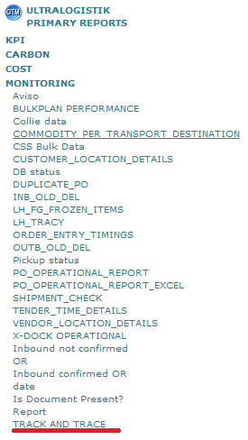

1. Report download

After you click above link below menu should appear:

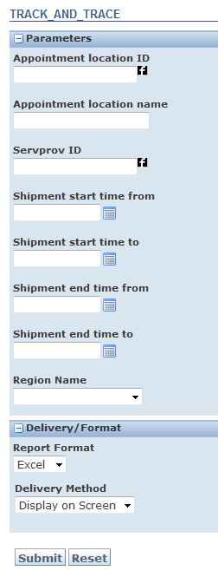

Appointment Location ID – You can type chosen location ID. The report will show both pickup and delivery appointments for this location.

Appointment location name – Reporting location name which you can find in location refnum value.

Servprov ID – Please type TSP ID whose transports you wish to see.

Shipment start time from/to – Please type shipment start time range.

Shipment end time from/to - Please type shipment end time range.

Please note that either Shipment start time from/to or Shipment end time from/to are mandatory fields. You always have to fill in shipment start time or shipment end time ranges. Please also note that maximum time range is 3 months.

Region name – Fill in desired region name. This is shipment refnum value.

1. Report Content

Data in the report contains all shipments which start/end date is in range of the values specified in the report filters described in point II. Additionally there is no cancelled shipments. Report downloaded from the system contains only blue columns described below. The rest black columns are a part of

separate file where you have to paste all data.



|  |  |
| --- | --- |
| **Sh Id** | Shipment ID |
| **Or Id** | Order release ID |
| **Dispatching Region** | Shipment region |
| **Source Loc Id** | Order source location |
| **Source City** | Order source location city |
| **Source Country** | Order source location country |
| **Dest Loc Id** | Order destination location |
| **Destination City** | Order destination location city |
| **Destination Country** | Order destination location country |
| **Service Provider** | TSP id |
| **Service Provider Name** | TSP name |
| **Number Of Eur Equ Pal** | Number of pallets on order release level in EURO equivalent |
| **Transport Cond** | Transport condition |
| **Shp Loc Category** | Sorce location category |
| **Material** | Material type |
| **Hazardous** | Hazardous goos flag |
| **Special Order** | Special order flag |
| **Express** | Express flag |
| **Orls Insert User** | Order release insert user |
| **Secure Res Status** | Shipment secure resources status |
| **Or Po Num** | Order release PO number |
| **Or Dn Num** | Order release DN number |
| **Sh Po** | Shipment PO number |
| **Sh Dn** | Shipment DN number |
| **Truck Plate** | Truck plate numbers |
| **Trailer Number** | Trailer number |
| **Stop Type** | Stop type P-pickup, D-delivery |
| **Stop Num** | Stop number |
| **Orls Insert Date** | Order insert date |
| **Sh Insert Date** | Shipment insert date |
| **Ordered date** | Planned arrival or order late pcikup date, depending which one is newer |
| **App Location** | Appointment location ID |
| **App Start** | Appointment start date |
| **App End** | Appointment end date |
| **App Dock** | Dock name |
| **Actual Arrival** | Actual arrival status date |
| **Actual Arrival Tsp** | Actual arrival status date provided by TSP |
| **First Status Insert Date** | Date when status was insert for the first time |
| **Registration In** | Registration in date |
| **Registration Out** | Registration out date |
| **Handling Start** | Handling start date |
| **Handling End** | Handling end date |
| **Delay Rc** | Reason codes on the shipment, stop |
| **Hours without status** | How many hours the status is (was) not entered by the TSP. |
| **Booking vs Ordered Date [if delayed]** | Is the truck going to be late either on pickup or delivery. |
| **Status vs Ordered Date [if delayed]** | Was the shipment picked up/delivered in line with ordered time. |
| **Register IN vs Ordered Date [if delayed]** | Was the shipment picked up/delivered in line with ordered time. |
| **Register IN vs Booking Date [if delayed]** | Was the shipment picked up/delivered in line with booked time-slot. |
| **Booking vs Ordered Date [H]** | How many hours before/after ordered time the truck is expected to arrive. |
| **Actual (TSP status) vs Ordered Date [H]** | How many hours before/after ordered time the truck arrived. |
| **Register IN vs Booking [H]** | How many hours before/after booked time-slot the truck arrived. |
| **Register out vs Register in [H]** | How long the truck spent at the site. |
| **Handling out vs Handling in [H]** | How long the truck was being unloaded. |